Accommodation
Accommodation with Friends - please tick what applies:
I/we would like overnight accommodation for
Friday [.....] Saturday [.....]
I/we have own transport and are willing to stay with a Friend
outside Aberdeen [.....]

I/we am happy to share a bedroom [.....]
(if answering as "I" and you wish to suggest with whom, please do so………………………………………………………………)

I do NOT wish to share a bedroom […..]

Please indicate any particular requirements you may have:
e.g. no stairs.

Return completed form to
Pamela Affleck, 53 Cameron Street, Stonehaven, AB39 2HS
Tel. 01569-762 592
email: apramtangle@btopenworld.com

by: Friday 25 October

Religious Society of Friends in Scotland
Residential General Meeting

16-17 November 2013
Crown Terrace Baptist Church, Aberdeen

“Taking Action for Economic Justice”

“We know that the world's resources are neither developed to the full nor used to the best advantage. The inequality in the distribution of goods and services between nations and between individuals within nations stares us in the face.
If we are to face these issues aright we are called to re-examine our whole way of life. At the personal level we must ask ourselves how we spend our time, and how we use the talents God has given us in earning a living, remembering that in spending we are asking others to use their resources in our service”
London Yearly Meeting 1968, from QFP 24.51
Our meeting in November will start on Saturday with refreshments from 10.15 am and then Meeting for Worship for Business at 11 am.
The Saturday morning session will include consideration of how to proceed with the appointment of a new Advocacy staff-member, on which discussions have been taking place with BYM Trustees.
Our speakers during the rest of our time together will be Suzanne Ismail from the QPSW Economic Issues project, and Val Brown of Christian Aid Glasgow. The overall theme will be on how to promote economic justice within a faith context. A current focus of Suzanne’s work is to assist Quakers and others explore what sort of economic system is needed if we are to live within the constraints of the Earth’s natural resources. Val will be informing us about Christian Aid’s campaign work for tax justice.
There will be a social activity on Saturday evening, and a further session on Sunday morning followed by worship and lunch.
Please join us in Aberdeen. Do encourage anyone from your Meeting to come who may not have attended GM before.

Venue information: All Saturday sessions and meals will be held in the Crown Terrace Baptist Church (see map, over page), where there is lift or stair-free accessibility.
The Sunday session, Worship and lunch will be held in the Meeting House,
98 Crown Street, which is fully accessible.

Accommodation:
Hospitality will, as far as possible, be provided by local Friends. We will try to accommodate everyone and will allocate on a first come first served basis. If we run out of bed spaces we will send you information on local B&Bs. Please note that whilst catering costs will be covered by General Meeting, commercial B&B costs will not.


Children and Young People:
There is no specific programme, but if we are notified by the closing date on the booking form we will arrange child care.
Please contact: Gail Nieman, 52 Camperdown Road, Aberdeen AB15 5NU. Tel. 01224 638 953.

Directions to Crown Terrace
Allow 10-15 mins from rail/bus stations if walking by Bridge St and Union St; 5-10 mins via steep steps.
Parking at the Meeting House for disabled Friends only. For other parking, see multistory car park on the map.
Booking Form:

Name:
Address:
…………………………………….…………..……Postcode
Tel:(home) …………………… Email:
Names of any others for whom booking is being made:

Do you require childcare? If so, please give name(s) and age(s):

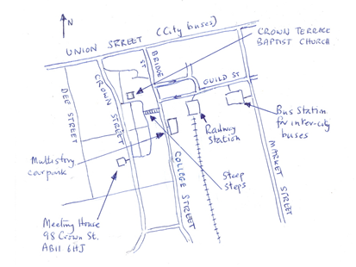
Meals
(please complete and return this, to help us with numbers, even if you do not require accommodation)

 | No. adults | No. children
Saturday lunch
Saturday dinner
Sunday lunch

All meals will be vegetarian. Attempts will be made to maximise fair trade and organic ingredients.

Do you have any special dietary needs? Please state below if vegan, or anything to which you are allergic (dairy, nuts, wheat etc)

P T O

