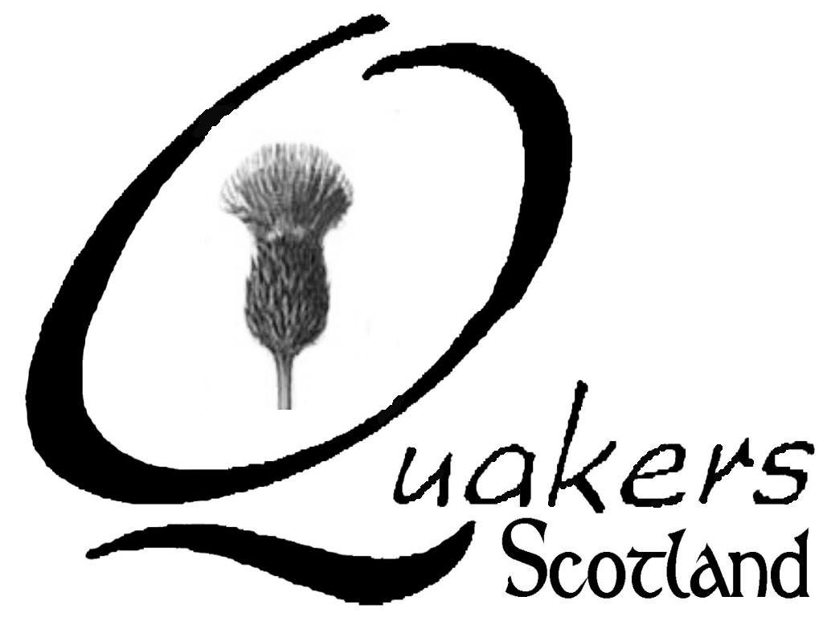
General Meeting for Scotland
Register of Skills, Experience and Knowledge

From time to time our our Representative Friend, or those working towards a greater involvement with the Scottish parliament, need to consult with Friends who have experience, skills or knowledge in a particular area. We therefore maintain a database of such information, which may also be shared with GM Nominations Committee.

We would like to know of any experience, skills or knowledge you may have (rather than just general interest), through either voluntary or professional involvement, in the areas listed below. Please be reassured that providing this information in no way commits you to taking on anything you do not wish or are unable to do! Very often it is just information or advice that is sought.

I agree to the information provided by me on this form being held within General Meeting for Scotland and used only for the above purposes.

Name: Date:

Local Meeting: Email:

When completed please return this form to
Bronwen Currie, GM Administrator, Taigh na Torraig, Bruichladdich, Isle of Islay PA49 7UN
or save and email as attachment to scotfriends@gmail.com

TOPIC | X | BRIEF OUTLINE OF EXPERIENCE
Children & Young People

Crime & Justice

Disability Issues

Ecumenical Relations

Education

Environmental Issues

European Union

Gender & Sexuality Issues

Health

Housing

Human Rights

Interfaith Relations

IT Skills

Legal Knowledge

Media

Mediation

Mental Health

Parliamentary or Local Government Issues

Peace Issues

Racial Justice

Slavery, Trafficking & Prostitution Issues
Theology
Other – Please specify

Any further comments:

Thank you!

